**Project Report**

**Pri-Cops Battleground**

**Submitted by**

**Imran Khalid** (FA-BSSE-054-B)

**Wajahat Ali** (FA-BSSE-057-B)

Session 2018-2022

**Supervised by**

**Ms. Tayyabah Hasan**



**Department of Software Engineering Lahore Garrison University**

**Lahore**

**Pri-Cops Battleground**

A project submitted to the Department of Software Engineering In

Partial Fulfillment of the Requirements for the Bachelor’s Degree in Software Engineering By

## Imran Khalid

## &

## Wajahat Ali

## Internal Supervisor

## Ms. Tayyabah Hasan

Lecturer

Department of Software Engineering

## External Examiner

## Chairperson

## Prof. Dr. Khalid Masood

Head of Department

Department of Software Engineering

**COPYRIGHTS**

This is to certify that the project titled “Prisoner Transport” is the genuine work carried out by **Imran Khalid** & **Wajahat Ali** student of BSSE of Software Engineering, Lahore Garrison University, Lahore during the academic year **2018-22**, in partial fulfillment of the requirements for the award of the degree of Bachelor of Computer Science and that the project has not formed the basis for the award previously of any other degree, diploma, fellowship or any other similar title.

Imran Khalid

Wajahat Ali

**DECLARATION**

This is to declare that the project entitled **“Pri-Cops Battleground”** is an original work done by undersigned, in partial fulfillment of the requirements for the degree “Bachelor of Science in Computer Science” at Computer Science Department, Lahore Garrison University, and Lahore. All the analysis, design and system development have been accomplished by the undersigned. Moreover, this project has not been submitted to any other college or university.

Imran Khalid

Wajahat Ali

**ACKNOWLEDGEMENTS**

We are very thankful to Allah Almighty who gave us courage and zeal to perform this work successfully. We have no words to express our feelings for our respectful teachers who are always beside us in every up and down. We are indebted to our most respected, well-learned advisors Ms. Tayyabah Hasan for his skilled guidance, encouraging attitude and keen interest in our work. We are also grateful to the entire teaching staff of Computer Science Department for their assistance and motivation throughout our working experience and providing us a strong academic atmosphere by enforcing strict discipline to do the project work with utmost concentration and dedication. We wish to reciprocate in full measure the kindness shown by Mr. Khalid Masood (H.O.D) who inspired us with his valuable suggestions in successfully completing the project work. We must say that no height is ever achieved without some sacrifices made at some end and it is here where we owe our special debt to our parents and our friends for showing their generous love and care throughout the entire period. Lastly, we would like to thank our project evaluators who spared their precious time to review our work.

# DEDICATION

**Dedicated to**

**Our Beloved Prophet Muhammad (SAW)**

**&**

**Our Loving Parents and Teachers**

**Table of content**

**Chapter 1. Introduction 1**

* 1. Background and information 2
  2. Product scope 3
  3. software and hardware requirement 3

**Chapter 2. Problem Definition 5**

* 1. Problem definition 5
  2. purpose 5
  3. Document conventions 5
  4. Intended audience and reading suggestions 5
  5. Product scope 6
  6. Product perspective 6
  7. Product functions 7
  8. User characteristics 7
  9. Functional features 7

2.10 Operating environment 9

2.11 design and implementation constraints 10

2.12 user documentation 10

2.13 assumptions and dependencies 10

**Chapter 3. Software Requirement Specification 18**

* 1. System features 18
  2. Single player mode 18
  3. Description and priority 18
  4. Functional requirements 18
  5. Play 18
  6. Move player 20
  7. Shoot 20
  8. Exit 21
  9. Other nonfunctional requirements 21

**Chapter 4. Methodology 23**

* 1. Research methodology 23
  2. Requirement management 23
  3. Unity 23
  4. Visual studio 24
  5. C sharp 24
  6. Implementation 24
  7. Project techniques 25
  8. Closing the project 25
  9. Methodology 25

4.10 Rad 26

4.11 Tools 26

4.12 Techniques 26

4.13 Dependency 27

**Chapter 5. Detail design and architecture 28**

* 1. System Architecture 28
  2. Use case diagram 31
  3. Class diagram 37
  4. Activity diagram 38
  5. Sequence diagram 41
  6. State machine diagram 43
  7. Dataflow diagram 43
  8. Entity relationship diagram 44
  9. State diagram 44

5.10 Component diagram 45

5.11 Data base diagram 45

**Chapter 6. Implementation and Testing 47**

* 1. Testing overview 47
  2. Unit testing 47
  3. Methodology 47
  4. Tools 48
  5. System test case 49
  6. Unit test 49
  7. User test 49
  8. Sound test 50

6.9 Result 50 6.10 black box testing 51

6.11 Acceptance testing 51

6.12 Software quality 51

6.13 Source code 51

**Chapter 7. Results and Discussion 58**

* 1. Testing strategies 58
  2. Animation controller test 58
  3. Blend tree 59
  4. Game testing 59
  5. Level selection 60
  6. Character selection 60
  7. Game scene 61
  8. Sound setting 61

7.9 Pause menu 62

7.10 Game over module 62

7.11 Level complete scene 63 7.12Choice menu 63

7.13 Models 64

7.14 Navigation and path setting 65

7.15 Building a navmesh 67

7.16 Creating a navmesh 68

7.17 Navmesh obstacle 68

**Chapter 8. Conclusion and Future Work 69**

* 1. The obstacles 69
  2. The achievements 69
  3. Future plan 69
  4. summary 70

References 71

# List of figures

FIGURE1: Flow Chart 24

FIGURE2: Methodology 25

FIGURE3: Use case play 31

FIGURE4: Use case how to play 32

FIGURE4: Class diagram 37

FIGURE5: Activity diagram new game 38

FIGURE6: Activity diagram resume game 38

FIGURE7: Activity diagram select level 39

FIGURE8: Activity diagram select player 39

FIGURE9: Activity diagram exit game 40

FIGURE10: Activity diagram new game 40

FIGURE11: Sequence diagram 41

FIGURE12: Sequence diagram state level 41

FIGURE13: Sequence diagram resume game 42

FIGURE14: Sequence diagram exit 42

FIGURE15: Sequence diagram 43

FIGURE16: State machine diagram 43

FIGURE17: Data flow diagram 43

FIGURE18: Entity relationship diagram 44

FIGURE19: Component diagram 45

FIGURE20: Data base diagram 45

FIGURE21: Rad methodology 47

FIGURE22: Animation controller 58

# Abstract

For most of peoples, video games are a normal part of their lives. Now a day’s entertainment is very important part of life. Without entertainment, life is boring as the quote says, “All work and no play make jack a dull boy”. Therefore, we are aiming to bring entertainment into the people lives. There is much to enjoy in the entertainment field and we are contributing a little bit into the people lives by making a game hoping that it will help people to relax and free their mind and enjoy it fully. The basic aim of the game is to implement and design a graphical game called “Pri-Cops Battleground”. It will include computer controlled intelligent opponents are criminals which are hidden in environment. Our goals are to design and implement the idea of Pri-Cops Battleground game by use of graphics primitives, this will involve animation for visual objects, and show a single player interacting with these objects. In this game, we have 7 levels. We have completed the current level to play the next one. After completing the level coins is given as a reward to the player.

# Chapter 1

## *Introduction*

## *. Background and Introduction*

Games are playing very important role in the life whether it is physical or computer games. Importance is that it develops hand-eye coordination in kids and adults. Games are also increasing the problem-solving abilities of the players. Lots of games are available on play store and the children find them through their interest.

* + 1. **Statement of work:**

The project under discussion is a completely common-user based and fully entertained Android game. A brief statement of work is given as below:

Using our Android based Application the user can get fully enjoyment and learn how to face the problems and complete its given objectives within the time. It is equally enjoyable for any age of people and children.

#### Project strategy:

The development of this project will follow the standard software development methodologies. Details can be discussed in other section. The developer will make use of mature technology frameworks. The following underlying technology, C# and java scripting services will be used if required.

#### Motivation for work:

The gaming industry is nowadays on the top in industries and its entertainment and stress relief for the users. Games are important in our life. Games is not wasted our time it’s tell the history and geography unintentionally. It develops the patience and tolerance I’m the user. Prisoner transport game us popular in the market. According to the research the people who playing the action games in life they made decisions 30% faster than others.

#### Goals and Objectives:

The goal of the user in Game is to find criminals, which are hiders of the game, also the main objective of the player. In this, the player finds criminals within given time the level complete and player get coins, for 3D objects are used. If the player will fail to complete its object within the time, game will be over and at this situation no reward for player.

* Provide a small system that entertains the peoples who are busy in our normal life and they have no time for outing.
* To develop a graphical game. This includes a cop like humanoid model (players), camera, a 3D environment, some icons (coins bar, enemy health, Timer) and interesting and joy full levels.

## *Project Scope:*

The Scope of the project is to capture the market on Play Store. Because there are many games in the market today, more than even we could count. A large number of games is daily developed and uploaded to the market for the entertainment of the people. Some of the games are puzzle games with small loading times and need a lot of brain power similarly there are games that are entertaining and also big in size and also take a lot of time to load and big game mission that are good for younger and people that are not busy so much but these games are not for the people that want to enjoy on the go so the aim here is to develop a game for the people that they can play this game for fun.

#### *Software and Hardware Requirements:*

#### Software Requirements:

* + - * Unity 3D
      * Mono Develop
      * Visual studio
      * Adobe Photoshop
      * Lucid chart
      * Star UML

#### Hardware Requirements:

* + - * Core i3 (1.7 GHz)
      * 4GB Ram
      * At least 250GB HD
      * Intel HD Graphic Card

##### Network Requirements:

An internet connection is required to browsing the game and uploads the result.

# Chapter 2

## *Introduction*

## *. Problem Definition*

The main problem is people is so much busy they don’t get time for fun and that is making people tense and depressed so the main aim is to help people get the entertainment they are looking for and to also provide a way for the people to pour their anger on so the feel relieved and relaxed after the game is finished. The game Prisoner Transport has unique idea this is the product of future and be placed on play store for gamers.

## *. Purpose*

The purpose of this documentation is to give a fully overview of the android prisoner transport game project (business title), including game engineer and UI. The document outlines all the hidden features and has decided to search for them now noting the importance and significance of their implementation.

## *. Document Conventions*

The development team is responsible for the Software Requirement Specification document therefore no difficulties arise from its use. This document is also printed on A4 size paper with the font of Times New Roman. 12 in black is Normal text size 12 and the section titles size is 24 in bold. Subtitles are in bold, size 14 is black, and third subtitles are in bold, size 13 is black. Bold fonts are used for main headings and bullets are used to introduce a new topic or a specific topic. The document is written in Times New Roman. The color of all headings and paragraphs would be black.

## *. Intended Audience and Reading Suggestions*

The document of SRS is planned for as developers, project managers, users and testers. The other documents of SRS carry the software, hardware, implementation, design of the game and more over. It carry the nonfunctional and functional requirements in the game.

## *. Product Scope*

The project scope is to capture the market on Play Store. Because there are many games in the market today, more than even we could count. A large number of games is daily developed and uploaded to the market for the entertainment of the people. Some of the games are puzzle games with small loading times and need a lot of brain power similarly there are games that are entertaining and also big in size and also take a lot of time to load and big game mission that are good for younger and people that are not busy so much but these games are not for the people that want to enjoy on the go so the aim here is to develop a game for the people that they can play this game for fun.

## *. Product Perspective*

Its implementation has been made possible by the ability to design and develop projects for use on Unity 3D game developers and Android devices. As part of its integration into the Android structure, and access to other applications against the security is guaranteed.



## *2.7. Product Functions*

There are following features that used in game are below explain and it’s divided into parts.

## *User Characteristics*

All internet game players from all over the world will be ability to user for the product. There is age limit as 5+. The only constraint for the users is being familiar with the rules of the games and known some about how to play Prisoner Transport game.

## Interface Requirements:

## Software Interface:

* + - * C#: is use for coding
      * Mono Develop: It also makes it easy for developers to port.

## *Functional features*

The major sections of the game are divided into the following categories. These sections are the most important part of the game.

## Title screen:

The first screen visible when the user /player starts the application, containing some

Buttons which help with the playback options.

## Menu module:

* Sound Settings

Users can off and on the sound.

* Control Setting

User can choose their favorite control (Arrow, Steering, Tilt, and Joystick).

## Vehicle Selection

* Vehicle Buy

In this module, the user will buy a Vehicle by using coins.

* Vehicle Specs:

In this module, user can see the about specs of any single vehicle like

(Handling, Speed, Brake, and Acceleration).

## Game Play with Fuel:

* + In this module, the user will Refill their vehicle through any gas station.

## Game Play Traffic System:

* + In-Game Module user will run his vehicle in traffic in the city.

## Game over Module:

* + In this module, the user will be rewarded with Coins.

## Shop Module:

* + In this module, the user would all levels and vehicles at once through the shop.

## Single Player:

* + This mode will have a single-player option where you will play against the enemies.

## Death zone:

* + The domain Area to raise the level reset, regardless of whether it contains traps such as

Stage boundaries or spiked nails.

## Pause menu:

Option to stop gameplay in-game and it also provides access to the player to see the features displayed on the title screen.

## User Classes and Characteristics

We have kept the control scheme of the game simple and the game play is also not something that is unfamiliar. It consists of simple design and the age difference doesn’t matter while playing the game. The user experience is what comes to matter while playing the game.

Two type of characteristics used like;

**Speed:** Speedily to finished the level and move to next level

**Intuition:** The ability to make successful game from guesses.

The skills and attributes to determine hardcore players will include:

* Login
* Main menu
* User/player name
* Bus selection
* Shop
* Daily rewards
* Map selection/level selection
* Speed: it is a potential/ability to overcome and to complete a level fast.
* Intuition: the capability to do successful attacks on enemies.
* Speed meter
* Fuel bar
* Controls
* Gear system

## *Operating Environment*

To game will be on Unity 3d only and it will support android 4.3 (Kit Kat) and above until android 8.1(Oreo). The android 9.0 (Pie) support will be included later. The android device must support minimum five-finger multi-touch support.

## *Design and Implementation Constraints*

The major constraints in design department for the development team will be to design environment in such a way that people don’t get bored of the stadium after playing it 2 to 3 times but to keep people attached to the environment or game play Moreover, the unlock able items should be so much great that people play in the game in desire to unlock the items such as new characters, stages and the powers. For the consumers the main problem will be that firstly, your device should be using an android operating system and secondly the device should not be outdated as it must have at least android

4.3 And the device should support multi touch at least up to 5 fingers.

## *User Documentation*

The game will come equipped with a separate instruction section bar in which the user when first start the game if wanting can go to the instruction section bar in order to learn t the mechanics or task of the game so that in their first time the user don’t get confused.

## *Assumptions and Dependencies*

The Game has mode of Single Player and with single player, the user can buy a friendly helping player that can help to find the hiders in the game.

## *External Interface Requirements*

#### User Interfaces

* + - * The Interface of this game will consist of multiple sections:
      * The user inter face when we start the game is consist of different screen the first one is splash screen which consist the name of the game.
      * The 2nd screen is about main menu that tells everything.
      * The third one is player selection scene.
      * In addition, the coming next is for level selection.
      * After select, the level game play is start.

**LOGO:**

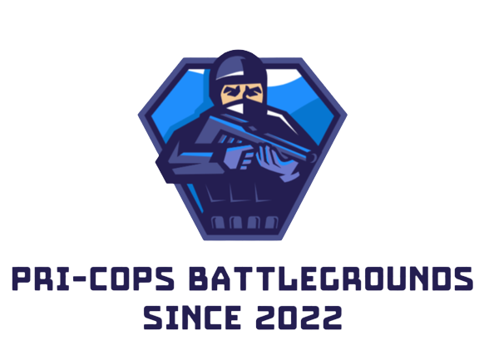

**PRIVACY POLICY:**



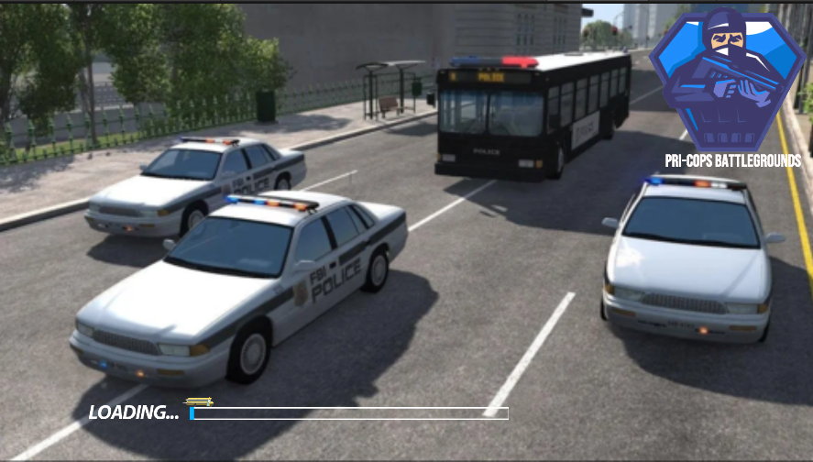**SPLASH SCENE:**

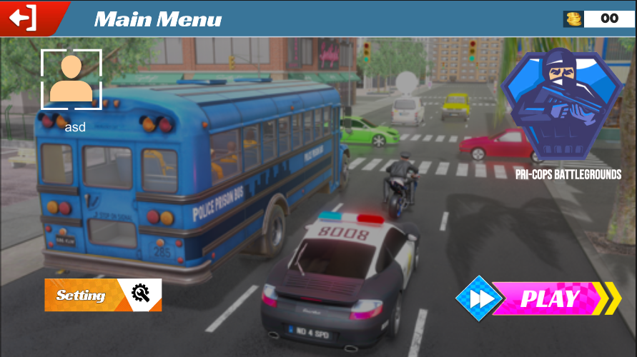**Main Menu:**

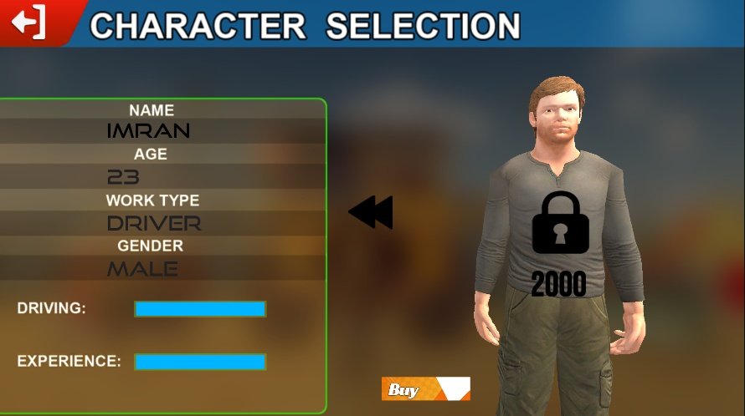**CHARACTER SELECTION:**

**VEHICLE SELECTION:** 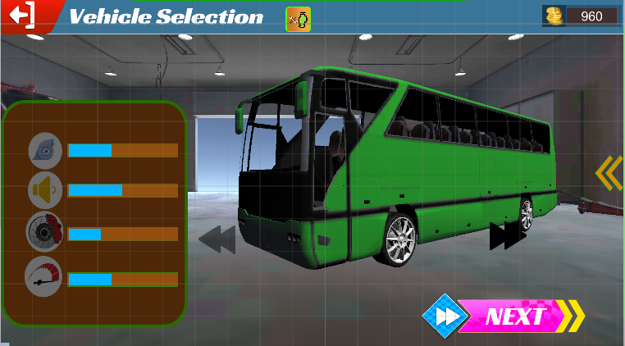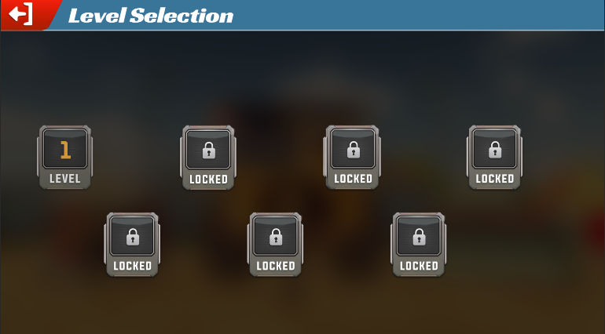**LEVEL SELECTION:**

**MAP SELECTION:**

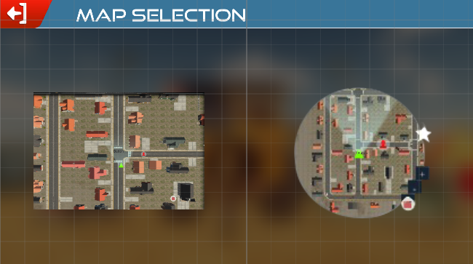

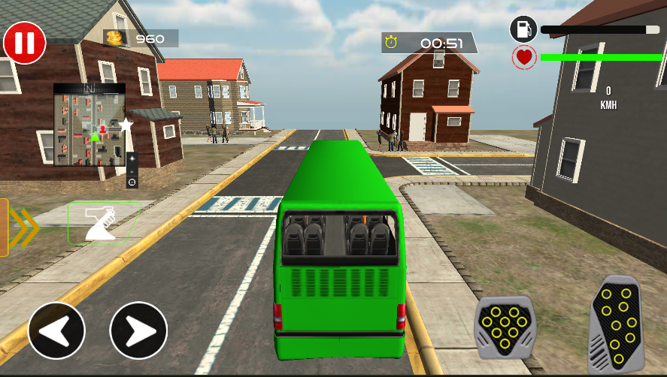**GAME PLAY:**

**SOUND SETTING:**

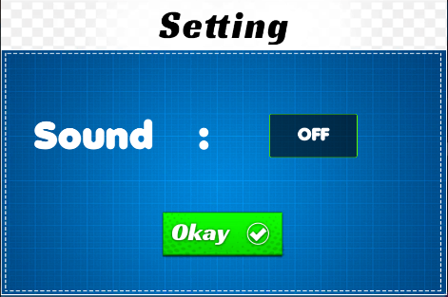

**PAUSE MENU:**

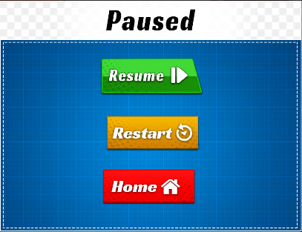

**GAME OVER MODULE:**

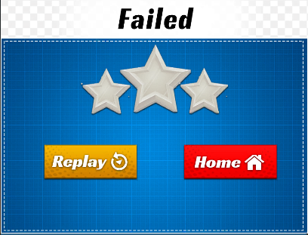

**LEVEL COMPLETE SREEN:**

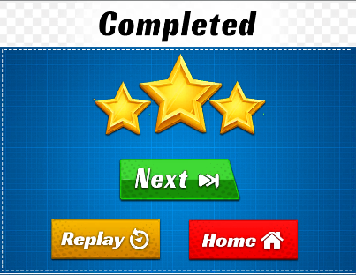

**EXIT MODULE:**

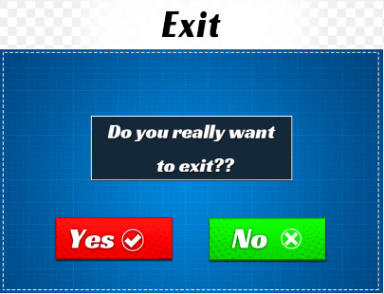

## *Hardware Interfaces*

The only devices that will be compatible with this game are the ones that will be using android operating system from version android 4.3(KitKat) to android 8.1(Oreo). This game will only be released for the android operating systems. The device must also allow a minimum of up to 5- finger multi touch.

## *Software Interfaces*

While developing the game on mobile phone, the most important thing in mobile is operating system to work the game on it.

Unity 3D have so much advantage s one is to easily develop game on 3D and used on mobile, computer etc.

Unity 3D have to ability to access the components.

Unity3D helping objects collision and interaction.

# Chapter 3

## *3. Software requirement specification.*

## *System features*

The functional requirements of our game are made by the developers these tasks tell the system that what should happen when a certain button is pressed and how the system will react on it and how the task will be accomplished.

## *. Single player mode*

This game mode has the highest priority among other game modes. This mode will allow a user to play the game against enemies programmed and after defeating the opponent you will get reward points that will enable the user to unlock new stages, characters, superpowers, and new vehicles.

## *. Description and Priority*

This game mode has the highest priority among other game modes. This mode will allow user to play the game against computer AI opponent and after defeating the opponent, you will get reward points that will enable user to unlock new stages, characters, super powers and new ball styles.

#### Stimulus/Response Sequences:

* Open the game
* Select the first ever section appearing on main menu
* You will go to the character selection screen. Select your desired character.
* After that, you will need to select the stage game will start.

## *. Functional Requirements*

* Character must be selected each time.
* The stage selection must be done by choice or can also be selected randomly.
* Purchase the friendly player for finding hiders.

## *Play*

#### Description and Priority

Play the game is the main part which complements the two players. This main part guides the user to the screen.

#### Stimulus/Response Sequences

* + - * User wants to play the game than users play game through android devices.
      * When the game start and user press play button, the game will start.

## *Move Player*

#### Description and Priority

* This section describes characters movement of the player.

#### Stimulus/Response Sequences

* + - * UP / DOWN
      * RIGHT / LEFT

#### Functional Requirements

* REQ-1: When users touches up button character shall move up.
* REQ-2 When user’s touches towards the lower button character shall move lower.
* REQ-3: When users touches left button the attributes shall move left.
* REQ-4: When user’s touches right button attributes shall move right.
* REQ-5: Motion of the activity shall interpret because of no light at the target place.
* REQ-6: Motion of activity shall interpret because target place is available not.

## *SHOOT*

#### Description and Priority

When the user can touch on hider, the player can fire or shoot the hider.

#### Stimulus/Response Sequences

* + - * Fire to catch the hider
      * Not found with the time game will over
      * Hider can change their location if they see you.

## EXIT

#### Description and Priority

User touches the exit button and game will close.

#### Stimulus/Response Sequences

* Game will close

#### Functional Requirements

1. REQ-1: Game is closed when touching the exit point.

1. REQ-2: Exit button available in the game and if want to exit through phone button the game will also exit.

## *Other Nonfunctional Requirements*

#### Performance Requirements

For any software development, we must need to build and design the software capabilities for a better work. The most important thing is we can be managed a system regularly and updating the system at the time. One of the most important requirements is the finding and removing the bugs that are installed whenever we updating the system.

#### Security Requirements

Prisoner transport game never wants any personal information of the users to start the game. Not to verify the identity of player to start the game. Just go on the play store and download the game and start the game of Prisoner transport simply.

#### Software Quality Attributes

To make sure the perfection of game, Prisoner transport answer the players on timely. On touch the Joyce stick (controlled the video games) than it will respond the users in seconds not in 10 seconds. The Prisoner transport game while the user play the game it’s automatically save the information of progress after complete the level and it would be in mobility. So it’s a good feature that the information will be save if the battery of phone gone but when again start the game the player should play game where it left not on the start.

#### Business Rules

The application will be working on the principles of android operating system, will be used by different no of individuals and will have different roles of them. This application is more effectively usable among small organizations who faces data transfer send chat issues; this app will provide both facilities in a single application. For commercial and public use, any platform can purchase it from us.

# Chapter 4

## *Methodology*

* 1. ***Research Methodology***

By far most or look into has done in the beginning periods of advancement process. There is a huge information about activity found on web and liveliness books. The vast majority of research has done on energized Games from 2D to 3D change. In this task we are doing deal with 3D activity of humanoid and creature characters.

## *Requirements Management*

The advancement of the venture needs a few necessities to improve the task perform and accomplishes the objectives of the undertaking. The prerequisites of the undertaking are overseen all through the advancement of the task. It is a persistent procedure of reporting, breaking down, following and organizing the prerequisites:

**Moral based story:**

* 3d character modeling
* Attractive environment
* 3d animation
* Visual effects audio and video

## *Unity:*

Unity is the basic tool for gaming, this tool using for game development of your project, it allows multiple languages and feature for development and it is used as development environment for visual studio. It helps in creating the supporting and write any type of codes for development. The project interpreter is selected as the visual studio file. This tool is also providing the terminal to run the commands directly such as executing the code and installing the project. The unity provides the all features for environments. There are suggestions available for every step as well.

## *Visual Studio:*

Visual studio is an integrated development environment. It is used to computer development program as well as websites, web apps and game development, this tool is multiple language and use for different development program, visual studio using for gaming and other multiplayers games as well as. It is being used for at the professional fields. We use visual studio for C-Sharp C# language.

## *C-Sharp C#:*

C sharp is a development environment in which you can web apps, desktop apps, mobile apps, games and much more. It is a general purpose, multi-paradigm programming language. It is developed by Microsoft in 2001. C sharp is suitable for writing applications for both hosted and embedded systems. It is being widely used for professional fields and is suitable for developing OOP applications.

## *Implementation*

In the implementation, process of the 3D animation short story it involves there important phases that is: Pre-production. Manufacturing. Post-production. There are another phases present inside that would be;

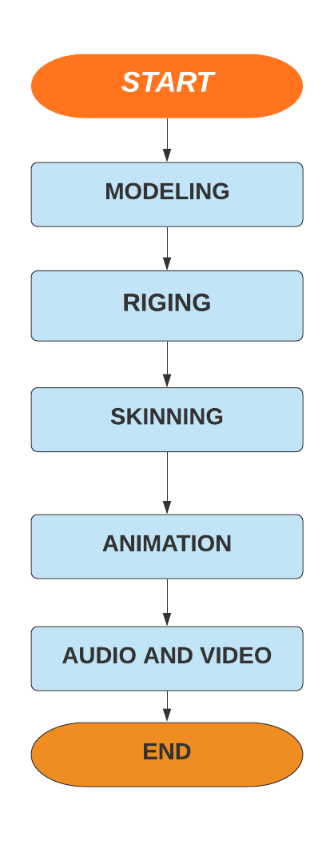

**Figure 1: Flow chart**

## *Project Techniques*

Examine and evaluation is the main key in any approach. Examine the program is done to guarantee that framework (for our situation the 3D Games) made really carries on as the desire for designer and meets client prerequisite. Testing is done all through the improvement of the task. Before the execution, testing was done on the equipment, programming, and storyboard of the Game. Amid the advancement of the undertaking testing is completed on the scenes and sound. This is to guarantee that the last Level of every scene is legitimately working and important with the Game plan Level. Amusement can be played on each stage for instance PC, mobiles, PCs and so on.

## *Closing the Project:*

When the venture is finished, an introduction will be given to the instructors and understudies of the office alongside the last documentation for the undertaking. This will show the improvement cycle and the last video of the Game. The undertaking Game and documentation will likewise be utilized as a portfolio while applying for occupations after graduation.

## *Methodology:*

RAD (Rapid Application Development) used for this project.

The common design of RAD is;

Requirement Plaining RAD design Performance

**IDENTIFY USER REQUIREMENTS**

**DESIGN THE SYSTEM**

**BUILD THE NEW SYSTEM**

**Figure: 2 Methodology**

## *RAD is chosen for the following reasons:*

* When the project in development stage the RAD need active time of user collaboration.
* RAD have an ability to change and updated the program on regularly.
* Most of time the project needs to completed in one year but due to RAD it will help in the development stage to completed in a shorten period of time and its helpful.

## *Tools*

Prisoner transport is android-based game. It has built in Unity 3D. Unity 3D works in C Sharp language. C Sharp language is used for coding or we are also says that it is back end language for making games in unity 3D the front end of the game based on UI of the game which are makes by photo shop. To run this application, android smartphone has used for this purpose. 3d models are used which are download free on unity asset store and rigged are applying animation by the website Maximo.

* + - Unity 3D
    - Mono Develop
    - Visual studio
    - Adobe Photoshop
    - Maximo
    - Visual code
    - Unity Asset

## *Technique:*

This application built over Unity 3d. It has Scenes and C sharp files connect these screens for backend. This game is the approach of physical game in which we can target only one module. Objective is to find required hiders in specific time. For the entertainment of the user, we can add sounds and some particles effects to make the user attention

## *Dependency:*

All the new versions of android can support this application except android 9 or sometimes it can crash on version 8 because we chose unity 5.6.2 it supports android 7 for the highest APK build. Few old versions of smartphones can also support but a new version of android studio provides high versions of operating system. It is all depends on the android version of smartphones.

# Chapter 5

## *Detailed Design and Architecture*

#### *System architecture*

Prisoner transport are well known game. In which plyer transport prisoner from one place to another place safely. In this game, we will change this idea a little bit or modified this idea by applying some new things on it. Our player is a Policeman model and his task is to find the criminals, which are hide somewhere in the environment. Player is controlled by a Joystick and when the player seen the criminal it will tap on it and the gun in hand of the player fires. Player has five bullets it will fire by tap on screen. This application is run on android Platform. The main responsibility of his game is to provide entertainment to the peoples who plays this game.

Prisoner Transport has a few functions.

##### Animations

Animations are a part of the game in this we can make animations where we can define different characters, which interact with the player model.

##### Title Screen

This screen is the player see every time while playing the game. Through the title screen the player get start another new game. It is the first screen when start the game. Main menu also including in the title screen.

##### Level Selection Menu

In this to have many options to choose different levels. The game is divided into chapters. Rating also including in the game for level selection. Level selection in the game to select the levels one by one and played Prisoner transport game having 7 levels.

##### Pause Menu

Pause menu is also important in Prisoner transport game, player needs to pause the game at any time.

The player to move between games allows in the pause menu and to select levels, and title screens. The portable nature of the console emphasizes the comfort of the gamer, so this feature should be included.

##### Fire

The fire function is the use to find and capture the thief when we tap on screen the fire function calls.

##### Dialogue or Tips

Dialogue is the only important way in which the player will experience the story of the game. Personal guide dialogue with a quiet character telling the context. Although this feature is important as the main mechanics of the game, it is an important feature of the game environment and level of design and music to enhance the player's relationship.

##### Timer

Timer always mention on the screen for checking the player should be complete its task within the time or not if not then the game will over.

##### Finish Point

Finish point is the ending place of the game. Firstly finished the level one and move toward the next level and then the ending the level and move to another level and that’s way the game is continued.

#### Architecture Design Approach

The architecture of the system can be seen through different perspective.

1. Developer.

2. Tester.

3. User.

For designing the system, the developer takes the whole perspective from the system. The functionalities of the system are considered. The designer maintains the system for all of the other roles to be used. Developer will develop the scripts for the project. The files to follow their operation using different paths. Their working to accomplish the task. While the tester will validate the software by checking the overall working of the software. The design follows the maintainability and flexibility; thus, it can be enhanced according to the future needs. The modules are divided according to the functionality of the components.

The user will play the game and predict the results and working of the game. So, the user can direct to give suitable suggestions. From this point the architecture has different perspectives.

* + 1. **Architecture Design**

Architecture diagram is collection of hardware and software components and their interfaces of smart board to establish the framework for the development of android application. How software and hardware interact. Smart Board interface is friendly and attractive

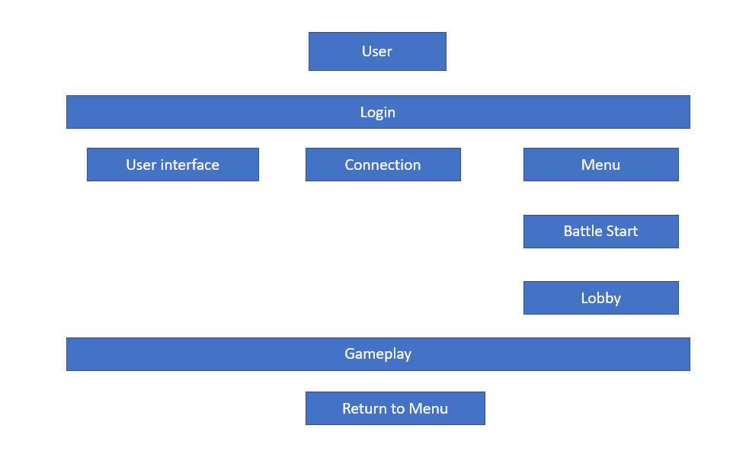

#### Use case Diagram

#### Introduction:

Games are playing very importance roll in the life whether it is physical or computer games. Good importance is that it develops hand-eye coordination in kids and adults. Games are also increasing the problem-solving abilities of the players. Children findings the game on their own interest, and then starting the game and see different levels and users wants to finish all and see different difficult levels one by one.

#### Use case Diagram:

In use case diagram there is representation of the game to how it would start, end and onward working. In use case diagram there is actors and the relation between the actors. In use case its clear there is selection, play, end, play levels etc. button available in the game.

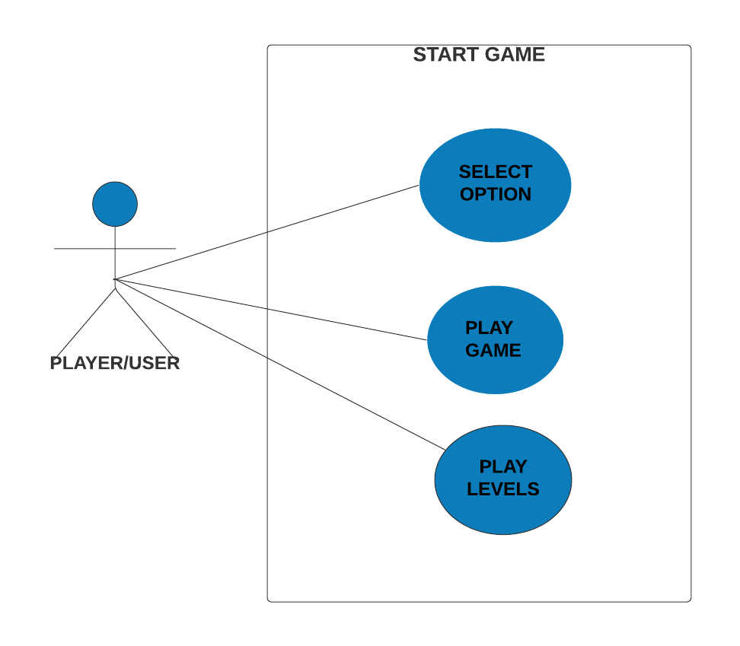

Figure 3: Use Case Diagram Play Game

#### How to Play Game

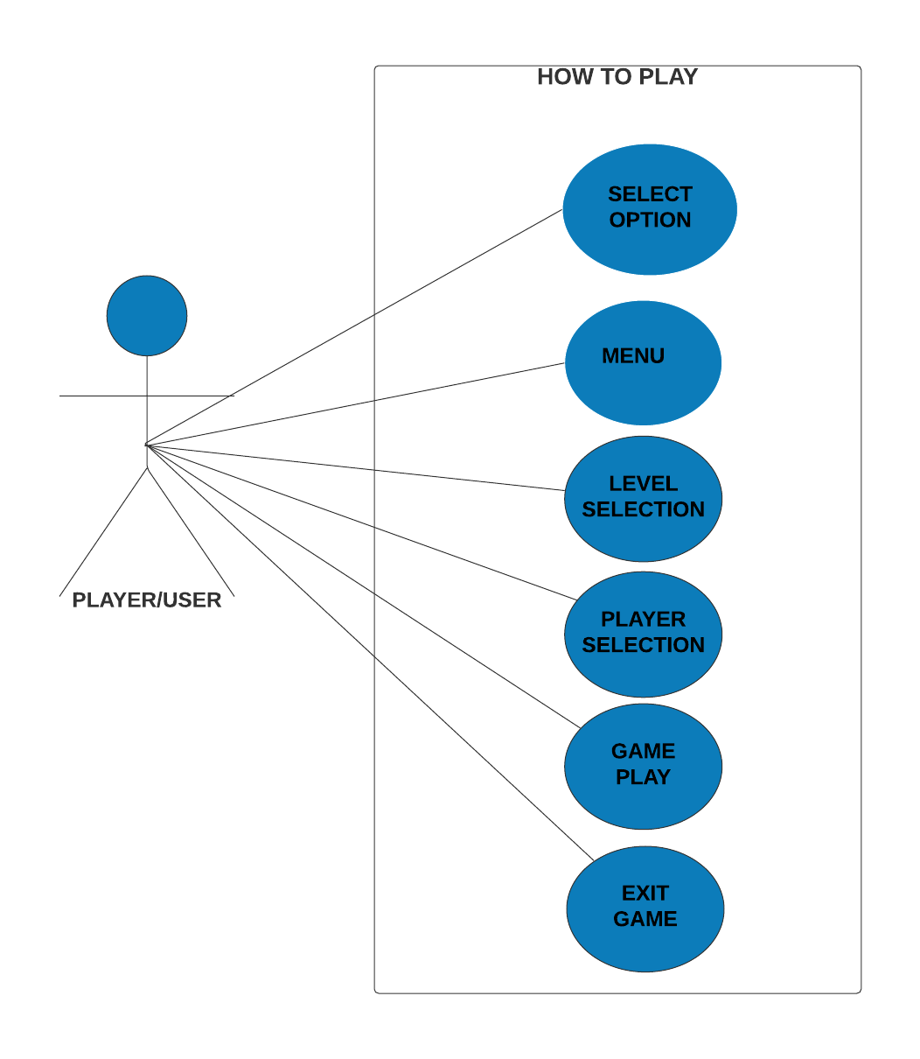

Figure 3: Use Case Diagram How to Play Game

#### Play: Use case

In play, use case represent the steps and accomplish the task and achieved the given goals and it is a New Game as well.

**Primary actors:**

* Actor is a user and it’s playing the game to achieve the goals.

**Goal in context:**

* It’s required before start the use case.

**Precondition:**

* It’s required before start the use case.
* Pre conditions is not an event.
* Pre conditions should true for use case/for use case it would be true.

**Triggers:**

##### The players needs to start the new game.

**Scenario:**

##### Open the game and go to menu

##### Start new game with new button available in game

##### While click on new button the new game loaded

**Expectation:**

##### The game faces some crashes in it.

**Priority:**

##### Important things must be implemented

**When Available:**

##### Gain

## Use case: Resume Game

**Primary Actors:**

Actors have start, end and resume point and on resume the point to keep the game resume. In this many player wants to play the game.

**Goal in context:**

##### Previous player to resume game

**Precondition:**

##### On resume game, the precondition is to played the game before

##### It’s not an event as well.

**Triggers:**

##### Player need to resume the game.

**Scenario:**

##### Open the game and go to menu

##### Start new game with new button available in game

##### Game is loaded

**Exception:**

##### Game faces some crashes like

##### Level not started

**Priority:**

##### Important points must be implemented first.

**When Available:**

##### Gain

## Use case: select level

* In game firstly select the level from 10 levels.

**Primary Actors:**

* Actor is a user and it’s playing the game and to achieve the goals.

**Goal in context:**

* From many levels to start the game and game will faces loaded action.

**Precondition:**

* Game faces the loaded action to start the level.
* It’s not an event

**Triggers:**

* To start game it would faces loaded action to move on the next level.

**Scenario:**

* Open the game and go to menu.
* Start new game with new button available in game.
* Go and click on level.
* And level loaded.

**Exception:**

* Level is loaded and level is not loaded.

**Priority:**

* Important points implemented firstly.

**When Available:**

* Gain.
  + 1. **Use case: Exit Game**

**Primary Actors:**

* Actor is a user and it’s playing the game and to achieve the goals.

**Goal in context:**

* In the game to exit

**Precondition:**

* Level is played

**Triggers:**

* if the players wants to exit the game

**Scenario:**

* In the game having a button to pause game
* After the game pause back to the main menu
* Main menu shows game exit and on title screen
* Priority: Important part implemented the firstly

**When Available:**

* Gain
  + 1. **Use case: Quit**

**Primary Actors:**

* Any of the user to play the game

**Goal in context:**

* In the game to exit

**Precondition:**

* To entered in game

**Triggers:**

* If player want to exit the game

**Scenario:**

* Main menu
* Touch phone back button to quit the game
* Finally game is quit.

**Exception:**

* Some issue in the game that to not exit the game and quit the game.

**Priority:**

* Important points implemented firstly.

**When Available:**

* Gain

#### *Class diagram*

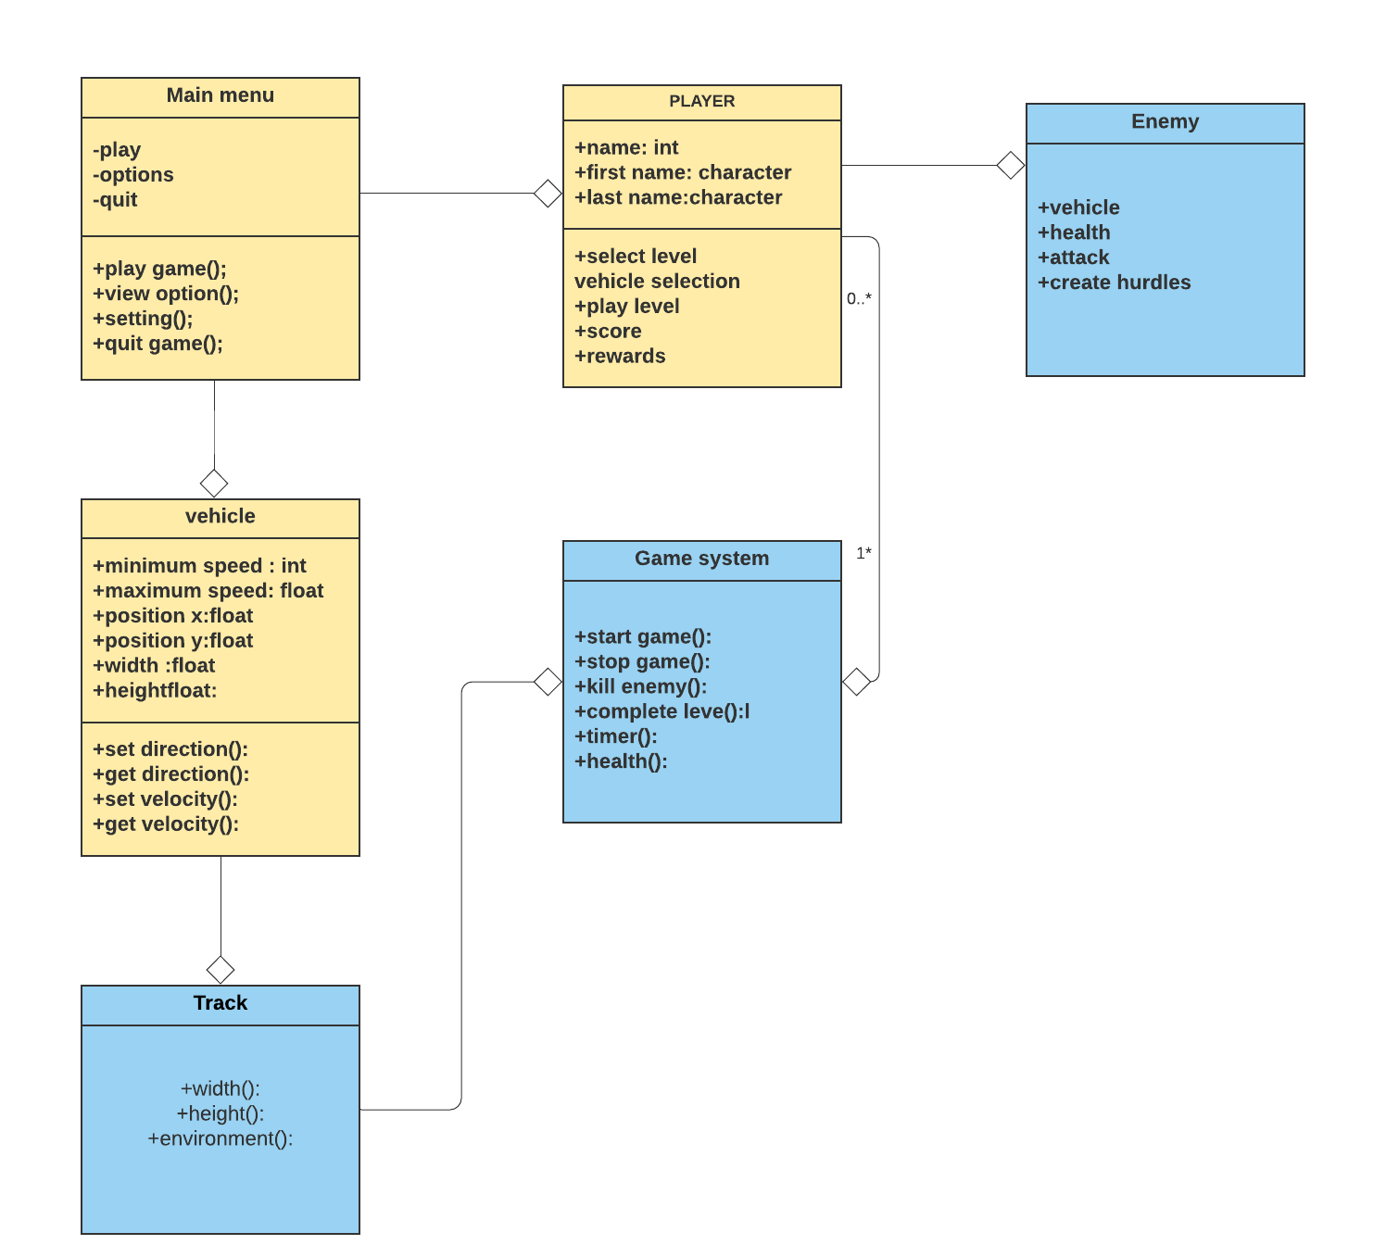

#### *Activity Diagram*

#### New Game” module of “Play”

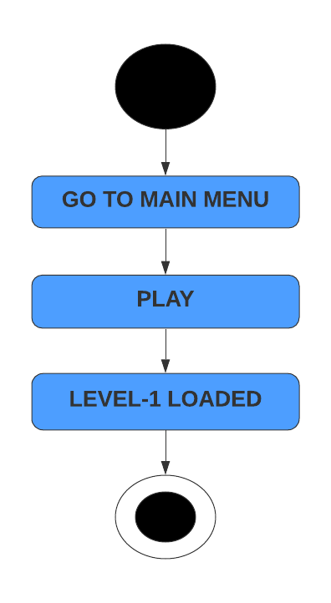

**Fig 4: Activity Diagram for “New Game” module of “Play”**

#### Resume Game” module of “Play”

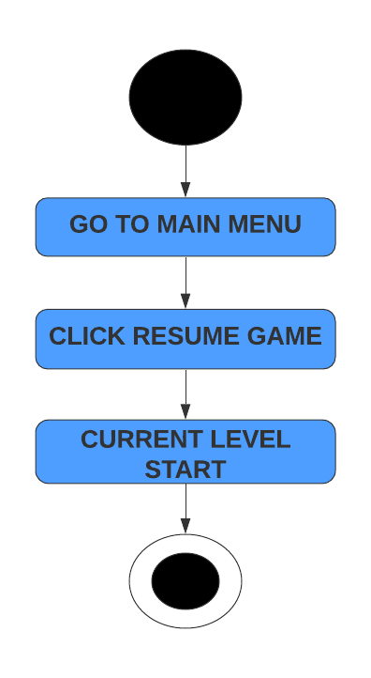

**Fig 5: Activity Diagram for “Resume Game” module of “Play”**

#### Select Level module of “Play”

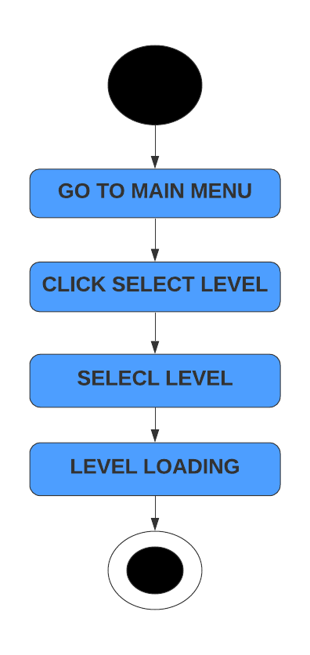

**Fig 6: Activity Diagram for “Select Level” module of “Play”**

#### Select Player

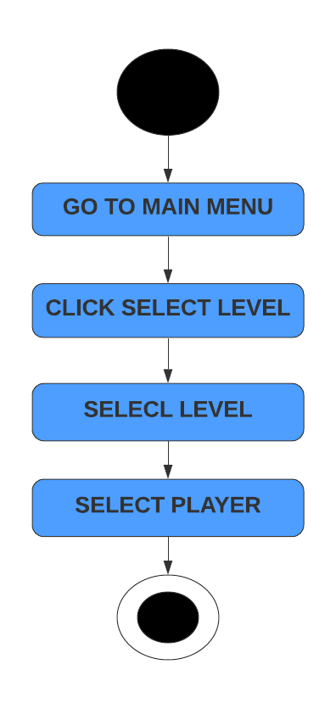

**Fig 7: Activity Diagram for “Select Player”**

#### Exit Game play

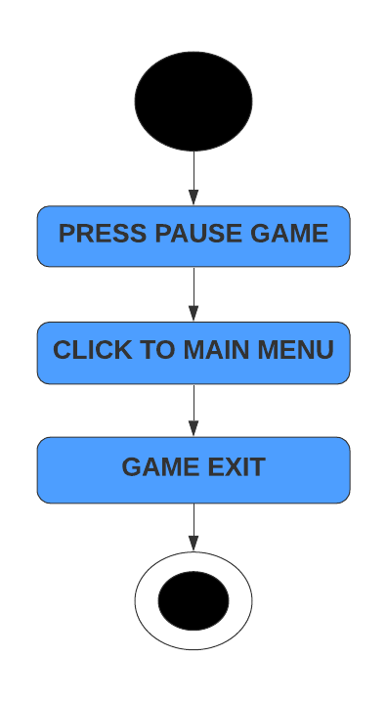

**Fig 8: Activity Diagram for “Exit Game play”**

#### *Sequence Diagram New Game*

#### New Game

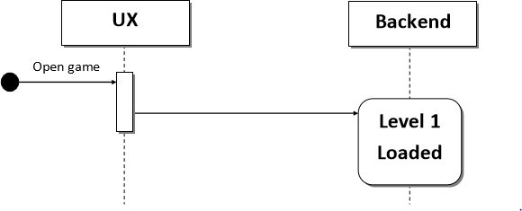

**Fig 9: Sequence diagram (New Game)**

#### Sequence diagram select level

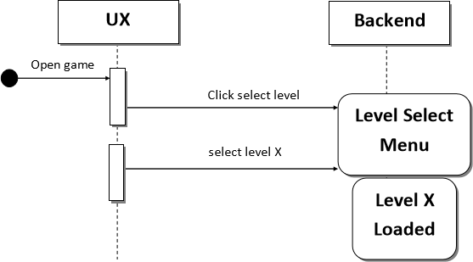

**Fig 10: Sequence diagram (Select Level)**

#### Resume Game

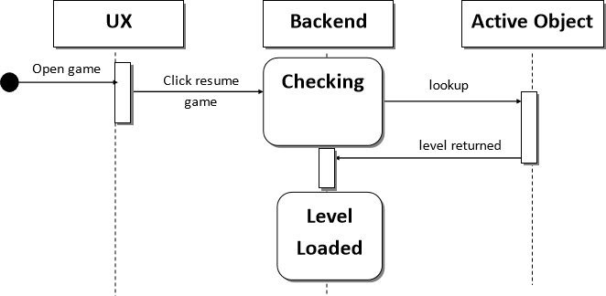

**Fig 11: Sequence diagram (Resume Game)**

#### Exit Game

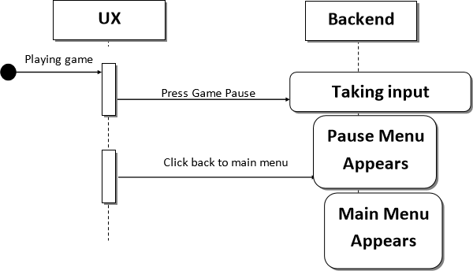

**Fig 12: Sequence diagram (Exit Game**

#### *State Machine Diagram*

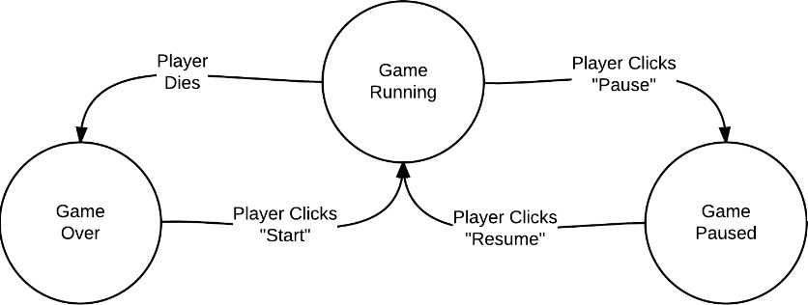

**Fig 13: play level state diagram**

#### *Data Flow Diagram*

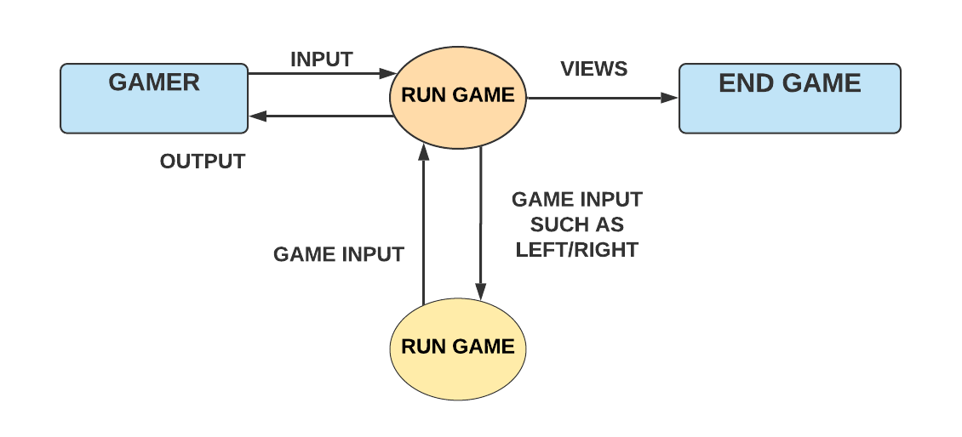

**Fig 14: play level state diagram**

#### *Entity relationship diagram*

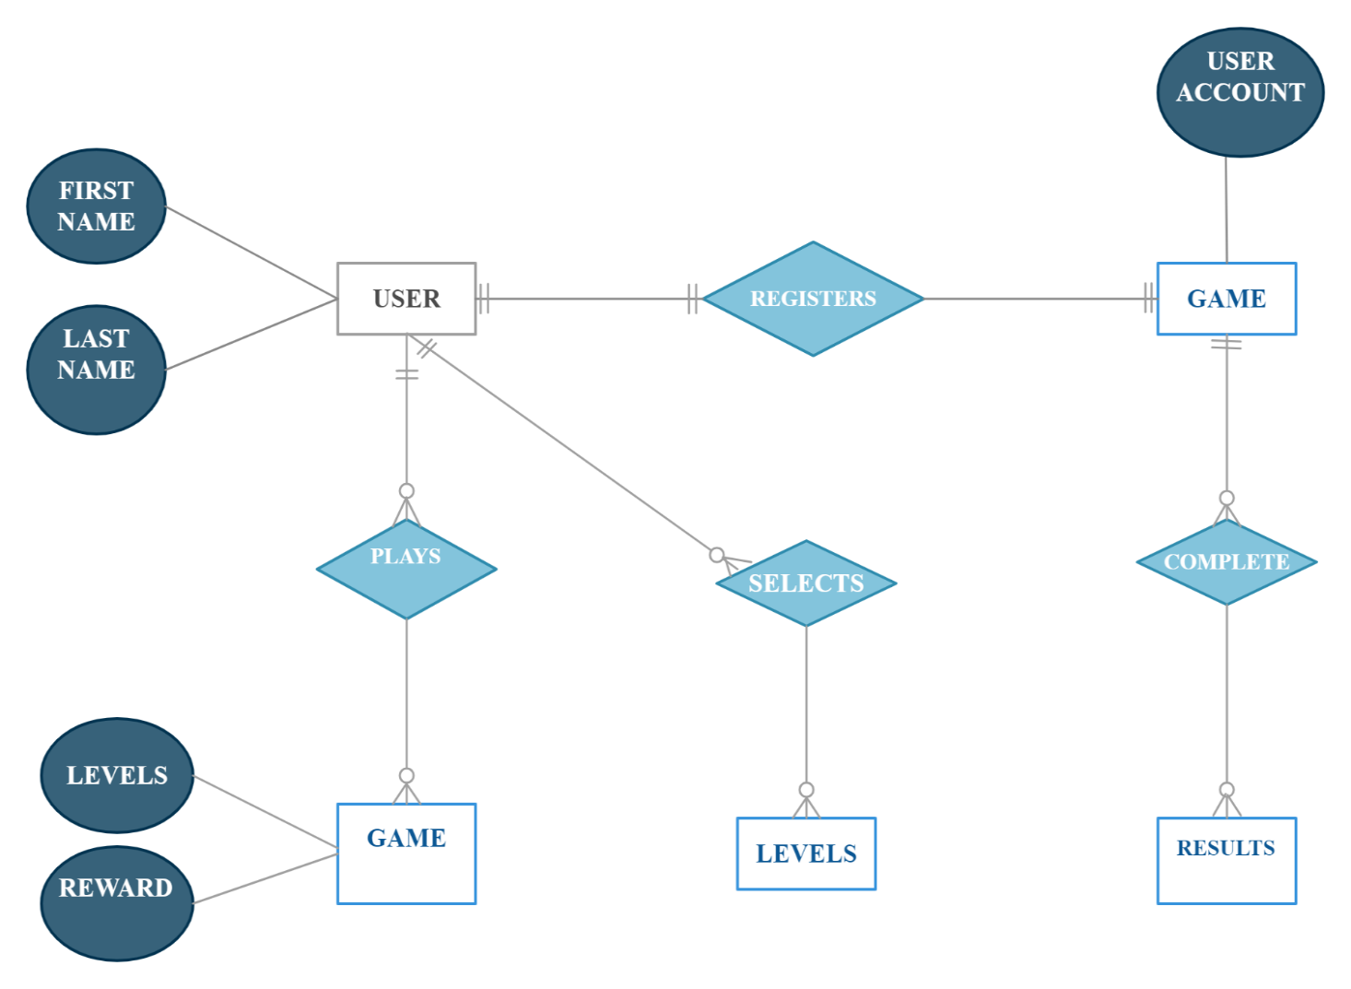

**Fig 15: entity relationship diagram**

#### *From Level Select, Level Complete*

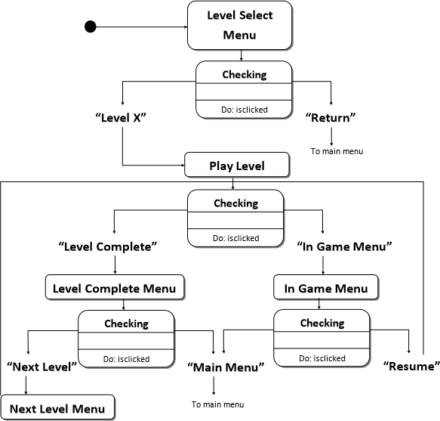

**Fig 16: play level state diagram**

#### *Component Diagram*

## https://documents.lucid.app/documents/f9eb32b9-c3c2-4225-b732-a0367f318e2a/pages/0_0?a=765&x=170&y=1495&w=1100&h=550&store=1&accept=image%2F*&auth=LCA%20659f22469a1bdd2643d2bfb95103e9f1bcd49a69-ts%3D1622475596

## Fig 17: play level state diagram

#### *Database diagram*

## https://documents.lucid.app/documents/f9eb32b9-c3c2-4225-b732-a0367f318e2a/pages/0_0?a=516&x=157&y=300&w=1690&h=880&store=1&accept=image%2F*&auth=LCA%200463cce8aedd762c5ecfb392b2ad29c6bc1662e2-ts%3D1622475596

**Fig 18: play level state diagram**

# Chapter 6

## *IMPLEMENTATION AND TESTING*

* 1. ***Testing overview:***

We performed three types of tests in testing

1st is unit tests

2nd is user tests

3rd sound tests when developed the game.

* 1. ***Unit Testing:***

In use of unit testing to figure out the modules of prisoner transport. All the functions are test separately. Each file and modules test against every type of condition and requirements.

* 1. ***Methodology:***

The RAD (Rapid Application Development) is the methodology used for this project. The common design of RAD is:

Requirement Plaining RAD design Performance

**IDENTIFY USER REQUIREMENTS**

**DESIGN THE SYSTEM**

**BUILD THE NEW SYSTEM**

**RAD is chosen for the following reasons:**

When the project in development stage the RAD need active time of user collaboration.

RAD have an ability to change and updated the program on regularly.

Most of the time the project needs to completed in one year but due to RAD it will help in the development stage to completed in a shorten period of time and its helpful.

## *Tools*

Prisoner transport is android-based game. It has built on Unity 3D. Unity 3D works in C Sharp language. C Sharp language is used for coding or we are also saying that it is back-end language for making games in unity 3D the front end of the game based on UI of the game which are makes by photo shop. To run this application, android smartphone has used for this purpose. 3d models are used which are download free on unity asset store and rigged are applying animation by the website Maximo.

* Unity 3D
* Mono Develop
* Visual studio
* Adobe Photoshop
* Maximo
* Visual code
* Unity Asset

## *Table System Test case*

|  |  |
| --- | --- |
|  | **System Test** |
| **Test Case ID** | **TC_04** |
| **Description** | **The full working of the game is checked in this test case.** |
| **Purpose** | **To detect the fighting scene** |
| **Pre-Condition** | **The game is started and at the end results are displayed.** |
| **Steps** | **The game starts after the loading.** |
| **Input** | **The players give the input by using keyboard to the character** |
| **Expected result** | **Game** |
| **Status** | **Pass** |
| **Remarks** | **Done** |

## *User Tests:*

In use of user test in Prisoner transport is to verify that the game is error free, and easy for the user to play and entertaining and its working good. One of us to check the game through all steps and check its working is good without the user was supposed to do help. And then we will show and make our game on the platform that the game is good and working excellent.

## *Table User Test case*

|  |  |
| --- | --- |
|  | **User Test Case** |
| **Test Case ID** | **TC_02** |
| **Description** | **The user interface will be made for the basic purposes.** |
| **Purpose** | **To make a good impression on the user.** |
| **Users** | **User** |
| **Pre-Condition** | **The designer will make a good user interface.** |
| **Steps** | **Setting player and playing animations and making.** |
| **Input** | **The interface will be displayed on starting the game.** |
| **Expected result** | **To display of the user interface for the other steps of game.** |
| **Status** | **Pass** |
| **Remarks** | **The user interface was successfully made.** |

## *Sound Tests:*

We insert some music in our game for better view. It is very effective for all users and enjoyable as well.

* + - Game Menu
    - Level Selection/Player Selection
    - Game Play

All three of objects having their own sounds, which will make this game very good and playable.

## *Table User Test case*

|  |  |
| --- | --- |
|  | **Positive Test Case** |
| **Test Case ID** | **TC_01** |
| **Description** | **The connectivity of the system will be checked.** |
| **Purpose** | **To check if the game is working online or not.** |
| **Users** | **User** |
| **Pre-Condition** | **The photon server will be integrated in google.** |
| **Steps** | **Start the game and check the proper connectivity.** |
| **Input** | **Start using the connections** |
| **Expected result** | **Game working fully online.** |
| **Status** | **Pass** |
| **Remarks** | **Done** |

## *Result:*

In the result of this game, we are covering mostly area of our code with unit tests. Probably when we will upload this game we will get good remarks from all users.

## *Black box Testing:*

Black box testing is a foam of software testing method in which the software check the internal structure of rules and solution without knowledge of it. The main reason of black box testing in the software is that it’s working on condition given in the documents and its meet the user prediction or not.

## *Acceptance Testing*

The software of the game will be deployed on the user’s system. The player will start the game and then after logging into the game he can start playing with other players. The game can be played on any system that will fulfil the software and hardware requirements. The system can be made compatible by performing the beta testing. The results are accurate to install it in the real time world. The game can work best with good graphics and conditions.

## *Software Quality*

The software quality depends on the number the factors i.e. the way system is performing the task the task to accomplish the goal. The performance of the game can be measured by its accuracy of detecting the players and their numbers in the scene. The game ends after the conditions are matched. It can also be enhanced by using the maximum resources of GPU and System efficiency.

The system is maintainable. The functionality of the system can be enhanced. The modules between the systems have low dependency on each other.

## *Source Code*

##### Splash scene

using UnityEngine;

using System.Collections;

public class SplashScene : MonoBehaviour {

// Use this for initialization

void Start () {

LevelSelection.startDialog();

StartCoroutine(lateStart());

}

// Update is called once per frame

IEnumerator lateStart() {

yield return new WaitForSeconds(3f);

// SabloSdk.Instance.ShowBanner ();

Application.LoadLevel("MainMenu");

}

}

##### Loading

using UnityEngine;

using System.Collections;

public class LoadingScene : MonoBehaviour {

// Use this for initialization

void Start () {

Time.timeScale = 1;

LevelSelection.startDialog();

Application.LoadLevel("GamePlay");

}

}

##### Main menu

cusing UnityEngine;

using System.Collections;

using UnityEngine.UI;

//using Soomla.Store;

public class MainMenuUI : MonoBehaviour {

// Use this for initialization

public AudioClip BtnClickClip=null;

AudioSource srcBtnClick;

public InputField InputField;

public string nameUser;

public GameObject NamePanel;

public Text UserNameTxt;

public static bool firstLoad = false;

public static MainMenuUI _instance;

public Text CoinsText;

public GameObject DailyRewardPnel;

private void Awake()

{

_instance = this;

}

void Start () {

if (PlayerPrefs.GetString("name") == "")

{

NamePanel.SetActive(true);

}

else

{

UserNameTxt.text = PlayerPrefs.GetString("name").ToString();

}

srcBtnClick=gameObject.AddComponent<AudioSource> ();

AudioListener.pause = false;

Time.timeScale = 1;

UpdateCoinsText();

if (PlayerPrefs.GetInt("DailyReward") == 0)

{

DailyRewardPnel.SetActive(true);

PlayerPrefs.SetInt("DailyReward", 1);

ProfilePIcShowFunction();

}

public GameObject[] PlayerImages;

public void ProfilePIcShowFunction()

{

print(PlayerPrefs.GetInt("Player" + 0));

if (PlayerPrefs.GetInt("Player" + 0) == 1)

{

PlayerImages[0].SetActive(true);

}

else if(PlayerPrefs.GetInt("Player" + 1) == 1)

{

PlayerImages[1].SetActive(true);

}

print(PlayerPrefs.GetInt("Player" + 1));

}

public void UpdateCoinsText()

{

CoinsText.text = Preferences.Instance.Coin.ToString();

}

public void btn_Play()

{

PlaySound ();

Application.LoadLevel("DriverSelection");

}

public void btn_RemoveAds()

{

PlaySound ();

}

public void btn_More_Fun()

{

PlaySound ();

public void btn_rate_Now()

PlaySound ();

public void ExitFunction()

{

PlayerPrefs.SetInt("DailyReward", 0);

Application.Quit()

public void SaveNameFunction()

{

PlayerPrefs.SetInt("DailyReward", 0);

nameUser = InputField.text;

print("Name" + "" + nameUser);

PlayerPrefs.SetString("name", nameUser);

PlayerPrefs.Save();

if (nameUser == "")

{

print("save name");

}

else

{

UserNameTxt.text = PlayerPrefs.GetString("name").ToString();

NamePanel.SetActive(false);

PlayerPrefs.SetInt("Player" + 0, -1);

PlayerPrefs.Save();

}

##### Level selection

using UnityEngine;

using System.Collections;

using UnityEngine.UI;

public class LevelSelection : MonoBehaviour

{

public AudioClip BtnClickClip = null;

AudioSource srcBtnClick;

public Button[] levels;

public Sprite lockSprite;

[Header("Multiple lock sprites")]

public bool multipleLocks= false;

public Sprite[] multipleLockSprite;

// Use this for initialization

void Start()

{

srcBtnClick = gameObject.AddComponent<AudioSource>();

Time.timeScale = 1;

for (int i = 0; i < levels.Length; i++)

{

if (i <= Preferences.Instance.LevelUnlock - 1)

{

levels[i].enabled = true;

levels[i].transform.Find("lock").gameObject.SetActive(false);

}

else

{

levels[i].enabled = false;

if (multipleLocks)

levels[i].transform.Find("lock").

GetComponent<Image>().sprite = multipleLockSprite[i];

else

levels[i].transform.Find("lock").

GetComponent<Image>().sprite = lockSprite;

}

public void btn_back()

Application.LoadLevel("MainMenu");

}

public void btnSelectLevel(int levelNum)

{

startDialog();

Preferences.Instance.Level = levelNum;

StartCoroutine(LoadLoading());

IEnumerator LoadLoading()

{

yield return new WaitForSeconds(1.5f);

Application.LoadLevel("LoadingScene");

}

public static void startDialog()

{

#if UNITY_ANDROID

Handheld.SetActivityIndicatorStyle(AndroidActivityIndicatorStyle.Large);

Handheld.StartActivityIndicator();

# endif

}

##### Finish point

using System.Collections;

using System.Collections.Generic;

using UnityEngine;

public class FinishPoint : MonoBehaviour

{

// Start is called before the first frame update

void Start()

{

private void OnCollisionEnter(Collision collision)

{

if (collision.gameObject.CompareTag("Player"))

GameManager._instance.LevelComplete();

##### Attacker

c using System.Collections;

using System.Collections.Generic;

using UnityEngine;

public class AttackerScript : MonoBehaviour

{

public LevelManager LevelMAnagerScript;

public int Damage;

public bool FiringAnmBool;

// Start is called before the first frame update

void Start()

{

private void OnTriggerStay(Collider other)

{

if (other.CompareTag("Player"))

{

LevelMAnagerScript.BusHealthFunction(.1f);

FiringAnmBool = true;

}

private void OnTriggerExit(Collider other)

{

if (other.CompareTag("Player"))

FiringAnmBool = false;

# Chapter 7

## *Results and Discussion*

In depth analysis of the program is to introduce with a supporting information and diagrams. System testing is worked across testing approach and the test type protect all of the use case type.

## *Testing Strategies*

Testing and evaluation is the main phase in any of program development. Testing is to ensure that the program will meet the user requirements and fulfill their needs and error free working (3D short story of animation). Testing will be done through all the time in the project on needs. Before the implementation of the program the testing is very important and test on many phases like on hardware, software and on portrayal. In the development phase the testing take a scenes and audio on it. This verify that the initial scene is support to working and its match with the story given to it. The game can do played on any of the platform like laptops, computers and mobiles.

## *Animation Controller Test*

## *Blend Tre*

* 1. ***Game Testing***
  2. ***Level Selection***

* 1. ***Character selection***
  2. ***Game scene:***



* 1. ***Sound setting:***



* 1. ***Pause menu:***



* 1. ***Game over module:***



* 1. ***Level complete screen:***



* 1. ***Exit module***



## *Models*

* + 1. **Helicopter model**

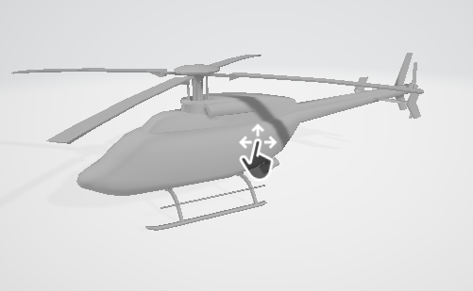

* + 1. **van model**

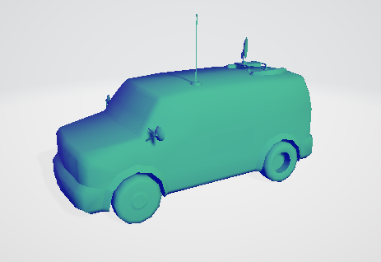

* + 1. **Car model**

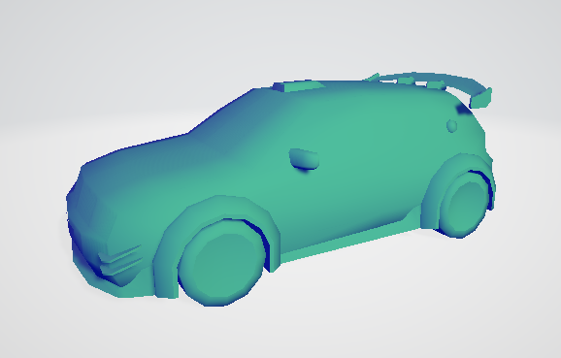

* + 1. **Bus model**

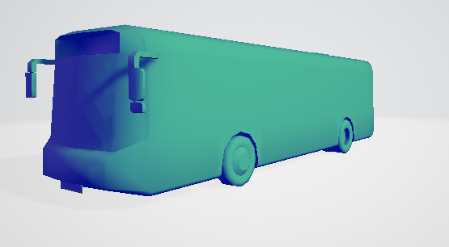

* 1. *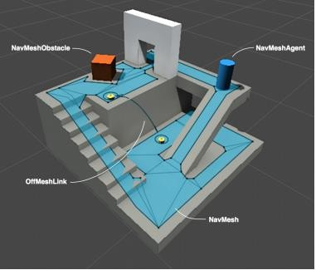****Navigation and Path finding***

The Navigation System is a character allow to create in game to move the world smartly. The navigation program works on navigation network that’s the reason about the environment. The navigation network are generate impulsive through the scene geometry. Dynamic interfaces in the navigation to allow the program of character at runtime and away the network links to make the actions such as opening door and down to jump from bulge. In this section to explain the navigation networks and path findings in depth. The navigation system is a character allow to create in game to move the world smartly. In this fits have ability to understand that if they are on stairs and need to go on 2nd floor and how to jump on the drain..So the unity NavMesh (short foam of navigation mesh) is consist of;

**NavMesh** is a data structure and the data structure is made or burn and impulsive from your geometry, that the data structure explain the wall surface of game and to pick the path of game from the location to another game world.

**NavMesh Agent** create characters that avoid while moving close their goal. Agents are the reason about the game world using the NavMesh and they know everything that how to avoid each other.

**Off Mesh Link** aspect permitting you to compromise navigation shortcuts which cannot be show the use of move on the surface. For example, leaping over a drain or a wall, or to open a door earlier than taking move on toward it, may be all defined as Off-mesh links.

The NavMesh (short foam of Navigation Mesh) allows to explain the rotating obstacles that the agent should ignore when negotiate the world. Example of obstacles is Barrel and Crate that would be handled by physical system. There are two ways of obstacles one is if the obstacles is stop the way than the agent is difficult to rotate and find different routes and if the obstacles open the way and moving the agents do their best to clear but if once the obstacles would stopped it will make a hole that the agents change their way.

## *Building a NavMesh*

The procedure of built a new mesh from root of mesh engineering is called baking. In the procedure, submit and terrain grids are added to all the objects in the game, which a distinct static navigation, and then lined up to generate a navigation net. Added that reaches the maneuverable levels in the aircraft. In the alliance, navigation mesh creation is managed from the navigation window (Menu: Window> Navigation). NavMesh can be created for your scene in 4 quick steps: navigation Determine the geometric location of the scene that will affect navigation: the levels and obstacles that can be navigated.

Enable static navigation to add selected items to the NavMesh Bread process.

Adjust the baking settings according to the size of your agent. The radius factor determines how close an agent's center is to a wall or edge. The height of an agent determines how far the agent can go. The maximum slope determines the steepness of the dealer's moving slope. The height of the stage determines the height of the obstacles that workers can step on.

Click Back to create New NavMesh

As long as the navigation window is open and visible, the new mesh will appear on the main geographic plane as a blue gown. As you can see in the pictures above, the nine mesh walkable area appears to have shrunk. New Mesh is the area where the dealer center can be moved. Imagine, it doesn't matter if you think of this element as a point on a navy mesh reducer or a circuit in a full size navigator, because the two are equal. However, point interpretation allows for better runtime performance and also allows the designer to see that the dealer immediately without worrying about his radius. Only it can pass through space.

## *Creating a NavMesh Agent*

Once you've baked NavMesh on your surface, it's time to create a character who can take the scene. We will build and run our prototype from a single cylinder. This is done using a navigation agent components and a simple script. First, we will create the character: Cylinder Create: Game Object> 3D Object> Cylinder. The dimensions of the virtual cylinder (height 2 and radius 0.5) l of the human shape element. They are good, so we will leave them. Add a new mesh agent component: Components> Navigation> New mesh agent

You now have a simple navigation agent setup ready to take orders! When you start testing New Mesh Agent, you can adjust its dimensions according to the size and speed of your character. The New Mesh Agent component handles both path search and character motion control. In your scripts, navigation can be as simple as setting the desired destination point - the new mesh agent can handle everything from there. Next, we need to develop a simple script that will allow you to send your character to a specific destination via another game object, and this field will be the destination.

## *NavMesh Obstacle*

* Navmesh barrier components can be used to define barriers that agents must avoid on the go.
* For example, In NevMesh the agents should ignore the items in motion like boxes and barrels.
* And on the top of stage added a box to block.
* 1st generate a cube to represent crate like Game Object > 3D Object > Cube
* Moving the cube and the size of cube is fine for crate so quit it.
* In the cube add the element of NavMesh Obstacle. Adding the element of inspector and Choose Navigation > NavMesh Obstacle.
* Rigid body adding to the obstacles and adding the element of inspector and Choose Physics > Rigid Body.
* Set the shape and if want to changing the shape of box its work automatically to fit the center and size of mesh.
* To on the carve setting because agents get the path easily around obstacles.
* Now working on a crate to generate a cube that is controlled, and the AI knowledge about to avoid the navigation.

# Chapter 8

#### *Conclusion and Future Work*

A software project gained a lot of experience from the development of program. The knowledge gained from development of the game of Pri-Cops Battleground is sum up in this section.

## *The Obstacles*

* Game engines is a new work experience to working on it that normally we see different languages when working on it.
* We gain these activities through videos, internet, and it’s a patience and hard work.
* It’s a very practical work and have much demands to develop a game.
* And the properties, Sections and sub Sections of retreat engines of game demands huge knowledge.

## *The Achievements*

* On this stage we now much know about the game engines. How does it work? Their valuables objects and else.
* On this stage we know how to build a style of model and how to active.
* Bottom line used that is a software engineer to ability to test the SRS documents and report of software are now good than before.
* Must be cooperate with the members of group.
* Enhance communication skills
* Knowledge to build up the imagination and creative thinking.

## *Future Plan*

* Enhance Graphical Representation
* Developed latest game features
* Enhance latest environment and scenes
* Level Extension

## *Summary*

Game is not only a fun but it is also a way of learning a lesson and increasing ability of a user. In this game, we will show a how to make a physical game in an android mobile game. This game is only a prospect of entertainment it also gives you the glimpse of real-world environment of how we can play hide and seek the core idea is same but deployment is change by making it is a criminal transport game. The basic aim of this project is to full fill the requirement of the BSSE (Hons.) degree and learn the new things related to computer science.

## *References*

1. Alan, D., Barbara, H, W. & David, D. (2002) System Analysis & Design: An Object- Oriented Approach with UML, john Wiley & Sons, Inc.
2. Pressman, Roger (2010). Software Engineering: A Practitioners Approach. Boston:

McGraw Hill.pp.123

1. Leffingwell, Dean; Don Widring (2003). Managing Software Requirements: A Use Case Approach (2nd ed. Ed) Addison Wesley
2. https://en.wikipedia.org/wiki/History_of_video_games/
3. https://unity3d.com/
4. h[www.unity.com/unitylearn](http://www.unity.com/unitylearn)
5. [www.unity.com/aseet](http://www.unity.com/aseet) store
6. <http://www.mixamo.com/>
7. [http://www.streetdirectory.com/travel_guide/103986/ga ming/effects_of_online_gaming_on_kids.html](http://www.streetdirectory.com/travel_guide/103986/ga%20ming/effects_of_online_gaming_on_kids.html)
8. http://learningworksforkids.com/2017/07/video-gamesprocessing-speed-research-recommendation(Dated 08/09/2017)